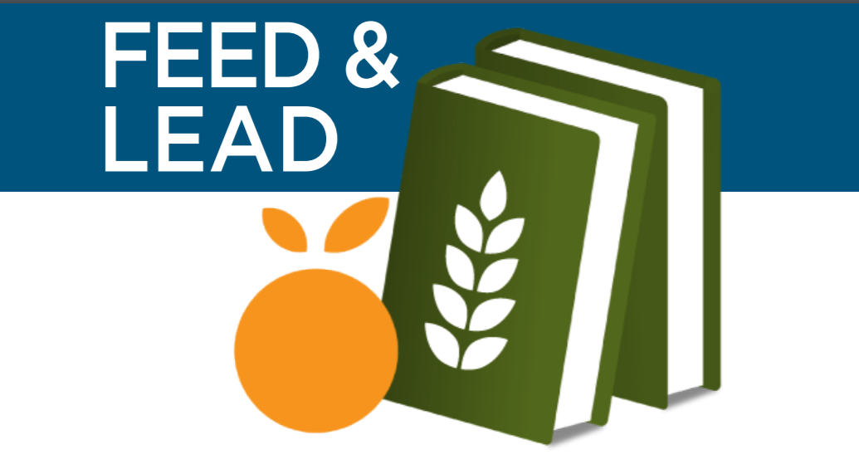

GRANT WRITING

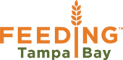

Karen Serrano Arce
kserranoarce@feedingtampabay.org
Cell 813.846.7313
4702 Transport Drive
Building 6 | Tampa, FL 33605
FeedingTampaBay.org
Feed and Lead Curriculum
Fundraising and Grants
Learn the difference between fundraising and grants.

Documents Needed
Learn what documents are needed when starting to apply for grants.

Grants Budget
Learn how to build a program budget for your grant application.

Grant Resources
Identify digital platforms to check when looking for available grants.

Grant Narratives
Learn how to tell your story in an impactful way when filling out your grant application.

Client Data Collection
How to conduct project evaluations and utilize data collection for grant purposes.

Grant Reporting
Learn how to report out on your grants in a way that is impactful and meaningful to your donors.

Fundraising
Before seeking grants, think about pursing less intensive options. Although grants can be very beneficial, they can take several months before receiving funding so they really should be sought after strategically. Often, there exist other development strategies that can achieve fundraising goals faster. Such as fundraising, sponsorships, and monthly individual giving.
Some good fundraising ideas that could raise money in a day is hosting a 5K or other fun runs and pancake breakfasts. There also exist less intensive options, like sponsorships. Agencies can offer a sponsor our van opportunity to partners where a magnet can be placed on an agency van. Or offering monthly individual giving. Feeding Tampa Bay offers partners the chance to be a fork lifter which means they are part of a group of individuals who participate in monthly giving.
Regardless of what you choose to do don’t forget to thank your sponsors. You can thank them digitally through newsletters or social media or in a physical way like making a partnership wall at your agency and putting their name up there.
Grants

There exist 3 main categories when it comes to grants: government, corporate, and foundation. Grants are generally for capacity building and strategic growth projects and should not be relied on as a main source of operating revenue.
Please always feel free to reach out to Feeding Tampa Bay and other food pantries, to help and support your grant applications! We should all work together to meet our mission.

Things to think about:

What kind of projects/programs do you want to seek funding for?

Would fundraising or a grant be the best way to seek funding for that project?

Notes:

Documents Needed
Financial Documents
Before you begin to write a grant, take a look and see if you have your financial documents ready? Basically for a grant you need a:
- Form 990,
- 501©3 determination letter,
- Annual budget and project budget.
If you don’t have your 990 on hand the IRS website can be used for your organization’s form. Here is the link:
https://www.irs.gov/charities-non-profits/search-for-forms-990-n-filed-by-small-tax-exempt-organizations
As for the 501©3 determination letter, that should be in your agency file so if you cannot find this then give Feeding Tampa Bay a call.
Revenues and expenses are the two main categories in the annual and project budget. Think about what your pantry spends money and write it down. Do you pay for gas? Rent? A maintenance fee? If you don’t spend money, then think about what gets donated and your volunteers’ time at the pantry.
Show Off
Once your financial documents are together, it is time to show off. There should be a section on the grant application where you can talk about your agency and how you leverage volunteers. One way you can show off your volunteers is to base the value of their services. In 2015 it was estimated a volunteer’s service was worth $23.56 an hour. So as an example, if you had five volunteers and they each worked 5 hours per week for the summer, which is a total of 12 weeks their services saved your pantry = $7,068 that summer. Volunteer services can also be used as matching funds by many funding sources. So make sure that you show that your agency enjoys community support!
How do you keep track of those hours? A volunteer sign in sheet is the easiest way to do so. Below is a simple sign in sheet, which you are more than welcome to use for your own agency. Later you can input the number of hours logged onto an excel sheet so that you can keep track of the total number of hours volunteered over the year.
Donations are another great way to show that your agency has the community support! Just like volunteer hours it is important to show off the amount of food and money that is donated to your agency, and what is done with it.
The Rest of your Documents
There’s two more documents that should be included in a grant application: the letter of inquiry and full proposal.
A letter of inquiry is a 1-3 page condensed version of your proposal. The letter of inquiry should be brief, no more than three pages and must be a short but a thorough presentation of the need or problem you have identified, the proposed solution, and your agencies qualifications for implementing that solution.
A full proposal goes into much more detail than your letter of inquiry. It should include an introduction and includes the name of your organization, the amount needed or requested, and a description of the project. The qualifications of project staff, a brief description of evaluative methodology, and a timetable should also be included here.
The organization description should be short and focus on the ability of your organization to meet the stated need. Provide a very brief history and description of your current programs while demonstrating a direct connection between what you do now and what you want to do with the requested funding.
The statement of need must convince the reader that there is an important need that can be met by your project. The statement of need includes: a description of the target population and geographical area, appropriate statistical data in abbreviated form, and several concrete examples.
The methodology should be appropriate to your statement of need and present a clear, logical, and achievable solution to the stated need. describe the project briefly, including major activities, names and titles of key project staff, and your desired objectives. other funding sources being approached for support of this project should be listed in a brief sentence or paragraph.
The final summary restates the intent of the project, offers to answer further questions, and thanks the potential funder for its consideration. Note: Only include attachments if the funder asks for them, and be sure to follow any guidelines for attachments.
Be Transparent
During the whole application, and after you are awarded the grant it is important that you be transparent. Grant-making organizations will see the whole financial picture once they have all of your financial documents so you may as well be honest with any deficient or negative periods, also give a brief statement of why this happened and how you’ve grown since then.

Volunteer Sign-in sheet
First & Last Name | E-mail | Time in | Time out
Thank you for being a #HungerHero! Please spread the word @feedingtampabay on FACEBOOK, TWITTER and INSTAGRAM!
Things to think about:

Do you have your financial documents in order and in one place?

How do you keep track of your volunteer’s hours?

Notes:

Grants Budget

When writing a budget think about all items that are needed for starting, running, or maintaining a program. Make sure that your budget matches your application and remember your audience.

Direct and Indirect Costs
Staff costs could be considered to be a direct cost. This includes personnel employed and training for them. Try looking at organizations similar to yours to get an idea on how this section should look like. Equipment and other supplies are other direct costs. Check with the funding source before starting on this section. Supplies should be well defined and include specifications so they may need to be broken down into categories.

Rent, utilities fees, trash pickup, and pest control are typically considered as indirect costs. But it is important to read through the grant guidelines first to know exactly what the grant makers allow to be funded.

In-kind Contributions
Volunteers and donations are considered as in-kind contributions and provides evidence that your program enjoys community support. Donations can be food or other items such as computers or building supplies. You should base and document the value of these services or good on their market value and can be matched by other grants or sponsors.

Financial Reporting
Make sure that you stay in your budget throughout the project timeline because you are going to need to report afterwards. Any adjustments that you need to make need to be asked to the funder beforehand.

Things to think about:

What are the direct and indirect cost of your pantry?

What types (and how much) of donations does your pantry have, and how do you keep track of those donations?

Notes:

Grant Resources

The first question that you need to ask yourself before applying to a grant is why do you want it? Is it funding for your food pantry in general? Or do you have a specific project in mind that you would like funding for? Are you trying to expand the facilities of the food pantry? Are you trying to cover the salary of a staff member? Or is there another reason why you would like a grant?
There is funding available for all of these areas, and more! But when you are going through grant applications you need to make sure that your particular funder will support your requested area.
Foundation Center
https://fconline.foundationcenter.org/
The Foundation Center directory is a great tool to use when searching for grants. You may sign up for this resource but it is also free to view at main libraries in Pinellas and Hillsborough. The center also included a how-to access grant video which walks you through how to search for grants.
An additional service of the foundation center is a newsletter, which includes current events as well as weekly grants that are available. Keep in mind that this includes all sorts of events, not just ones specific to food pantries so you may have to do a little bit of digging. You can however, go on the website and search under RFPs which stands for Request for Proposals for more specific information. And depending on what you click will take you to currently active RFPs which you search for free, gather more details, and possibly apply.
Diane Leonard Consulting
https://www.dhleonardconsulting.com/
Diane Leonard Consulting’s goal is to assist nonprofit organizations in increasing their grant readiness and to help them competitively apply for and successfully manage grant funding. On their website you can sign for their 30 day grant readiness challenge which gives you daily tasks to ensure that you are ready to write a grant by the end of the month.
There is also the Grasp tool which includes a series of questions that you answer and in the end it tells you what your pantry’s level of grant readiness is. It’s great for anyone to go through and see where to improve. Diane Leonard Consulting also has a newsletter which you can sign up for to get up to date information regarding grants.

Community Foundation of Tampa Bay
http://www.cftampabay.org/request/competitivegrants/
On the community foundation of Tampa Bay’s website you may apply for grants online. Grants from them are awarded on a scheduled throughout the year and the areas that the community foundation focuses on are education, arts and culture, health and/or human services, environmental restoration and/or animal welfare, and emerging needs.
They do stress that all grant proposals should be completed online unless otherwise noted. And to pay close attention to the instructions before you begin the application process.
Other Resources
Here are two other links, not related to any of the three examples that were provided in this session but still valuable resources.
Federal Grants Management 101 Training
https://cfo.gov/grants/training
This training is a valuable resource for potential grant recipients and their staff that are dealing with Federal grants.
Community Development Grants
http://www.communitydevelopmentgrants.info/infoWebsites.aspx
The website grantsoffice.info has a group of websites dedicated to the latest in grant information for a wide range of popular grant categories. However, the link included leads specifically to the community development grants that are listed on their website.
Things to think about:

What do you want funding for?

Do you have a volunteer who can take on writing grant applications?

Notes:

The Mysterious Culture of Grants
Grant Narratives

Grants are sometimes considered mysterious and there exists many myths about them.
- Myth: grants are sometimes for nothing. Reality: Grants are rational deals between colleague
- Myth: Writing Proposals is an ordeal. Reality: Proposal writing is predictable and simple.
- Myth: All you need is one well-written grant proposal. Reality: Winning grants depends on pinpointing matches and tailoring proposals
- Myth: You need to “know someone” to get a grant. Reality: You don’t need to know anyone to start, and relationships can be built as you go.
Planning for Grants
When planning for grants the first step is to define the scope. What is the problem that your program is trying to solve? Why do you need this money? What is your solution? If you were to get this money what would you use it for, how could it help? What are your qualifications? What makes your pantry unique? What are your barriers? What else do you need? And how will you measure success?
The second step is to know what to do. Just like dating, you only get one chance to make a first impression to grant funders. Make sure that you speak the same language as the grand funders. Try not to use acronyms in the proposal, although you and the volunteers at your pantries know what they mean the grant writers may not. Do not climb on board the money train. If you see a grant for something that does not match the mission of your pantry, don’t chase it even though it may be offering a lot of money. Be specific and stay true to your mission.
Then you can start structuring a grant narrative, the following are typical elements that are needed for a grant.
- Cover Letter
- Summary/Abstract
- Background
- Statement of Need
- Objectives
- Methods
- Evaluation
- Future Funding
- Budget

It’s All Logical
Grant writing is all logical. So another way to plan and structure a grant application is to use a logic model.
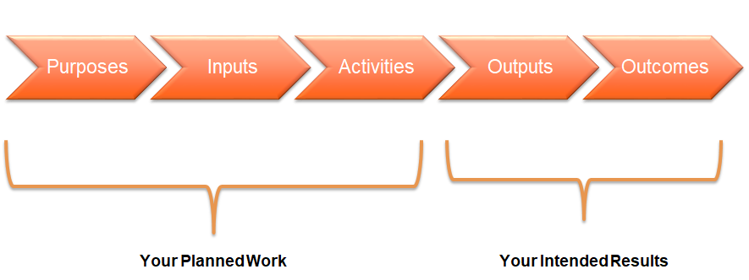
- Purposes/Goals: Documents the needs to be met or problems to be solved by the proposed funding.
- Inputs: The resources dedicated to the proposed program (e.g., time, staff, equipment, space).
- Activities: The major program elements designed to accomplish the goals of the grant (e.g., to create, to provide, to develop).
- Outputs: The direct products of the activities planned, measured in terms of volume of work (e.g., number of people served, number of applications reviewed, numbers of hours spent in an activity).
- Outcomes: The anticipated, long and big range, benefits resulting from the program activities (e.g., will increase, will impact, will change).
Project Narrative
The project narrative provides the meat of your grant proposal and should supply all the details of the project. This is why planning the logic model is so important! Once you have that part done, this becomes easy. This section may require several subsections. but at the end project narrative should answer all of the reviewers’ questions and not leave them wondering about anything.
If you are completing an online application where you have a response box per question, this structuring of the program narrative has already been done for you. However, if you are writing a separate narrative that has to be uploaded or mailed, then it’s up to you to set up the narrative in a way to correspond with the questions or the scoring rubric that you are given.
RFPs (Request for proposal) commonly categorizes questions into four numbered categories: Need for Program, Program Design, Management, and Evaluation. If the RFP lists these categories, make sure you structure your narrative around them.
The first section is the need for program. When talking about the need for your program answer just that, why is the community in need of your food pantry? Give a little bit of background, could it be because 1 in 7 people in Tampa Bay are food insecure? And what does your program do to address this issue? If you have any prior data or numbers, it would be great to include in this section.
Then, talk about your program and how if you are awarded this grant what the design of the program looks like. What is the strategy for implementation? Talk about the goals and objectives of the program and how the activities tied to them.
In the management section include a list of staff involved in the program, their capabilities, and prior experiences. Some grant proposals do ask for resumes but most just require a brief summary. Also mention what the plan is for sustaining the project after funding ends? Keep in mind that grant funding is not guaranteed every year so a plan for later is always a good thing to have.
Finally, include a section on evaluation. What is the expected impact of the project? And how to you plan on measuring that success? This can seem a bit like you;re repeating yourself but it’s always useful to tie things back into the goals and objectives.
Again, make sure that you structure your narrative around the categories that the RFP may list, the four that were mentioned are commonly used but that’s not guaranteed so pay attention to the guidelines.
The narrative may not look like a beautiful essay, it may look choppy and it may not flow well, especially if the criteria is in a strange order or repeats itself. However, by following the structure given to you, you will have directly answered the questions and the reviewer will be able to easily find the information that they are looking for without having to hunt for it.
Goal Setting
Most RFPs do ask for program goals. It is useful to make your goals as precise as possible and make sure that they are linked to your outputs. Let a donor see that a contribution to your program could help you accomplish something doable. Statistics are great to use as a benchmark to make a goal seem more concrete and achievable. But be realistic, remember that at the end you will have complete an evaluation to measure the success of your program and will have to report how you did back to your donors!
Things to think about:

Why does the community need your project/program?

What are your goals for this project/program?

Notes:

Client Data Collection

Data: The Big Picture
Data are facts and statistics collected together for reference or analysis. By collecting data, an organization has more scope to improve its service model and reach more people efficiently and effectively. Feeding America is currently undertaking a nation-wide study that is exploring food bank data collection methods to find best practices for our network.
Understanding your clients helps you put your clients’ current needs first and better serve your community. Client level data can be used for reporting to donors and Feeding Tampa Bay, marketing purposes, grant applications, and inform decisions related to program improvements.
Type of Data
Understanding your clients helps you put your clients’ current needs first and better serve your community. Client level data can be used for many things including:
- Reporting to Donors and Feeding Tampa Bay
- Marketing Purposes
- Grant Applications
- To inform decisions related to program improvements
The type of data that you collect is all determined by what information you are seeking.
Who, where, and what client data is information that helps you understand who you are serving and where your clients are coming from. This includes:
- Zip Code
- # of People in Household
- # of Children
- # of Senior Citizens
- # of Military Veterans
- Dietary Restrictions?
- Need for SNAP assistance?
Why data includes information that helps your agency understand why your clients are in need so that you may be able to better assist or refer them to the resources they need. This information could include:
- Needs and Challenges
- Health Status/Needs
- Opportunity to partner with healthcare providers
- Tough Choices Question (i.e. have you had to put off buying medicines so that you have enough money for food?).
This is the opportunity to understand the tough decisions your agency’s clients have to make on a regular basis and will help you better understand trends in your community.
Ethic on Data Collection
A client should never be asked to give information in order to receive food. If a client does not want to provide you with any information, they don’t have to. It may be disappointing but they do have the right to refuse. Once you have that data, keep it private.
Do not collect names or other identifiable information. Overall numbers should be shared but not individuals. Client stories are exceptions – but a waiver is required.
Data Collection
There’s many ways to collect data. The first is the old fashioned way with paper forms. Collecting data on paper forms is the simplest option and later that information can be inputted onto an excel sheet for a database of client info. However, keeping track of the paper forms can be tricky, they can get misplaced. and they can easily be damaged (especially when it’s raining). Also, inputting the information into an excel sheet is very time consuming and is not easily analyzed. An alternative option is to input all the data directly onto a Google sheet using a tablet or to use Google forms. Not only is Google forms is free and paperless but it can collect all your data in one place. This website creates charts and percentages immediately and can create a spreadsheet, if needed. An advantage of Google form is that Good will allow 501 © 3s to build a website and will host your website for free if you buy the domain name at about $10 a year.
Got Data, Now What?
Data is valuable because it can be used to inform decisions. The data you decide to collect should be helping you answer a question about your clients, your community, and/or your organization. It should inform donors and Feeding Tampa Bay of growing needs, which in turn can should help you write grant proposal to address community needs. It should also inform stakeholders through marketing of community need and organizational impact and improve organizational programs to better meet the needs of your community.
Things to think about:

Does your pantry already collect data? If so, what can you do with it?

If you don’t collect data now, what type of data would be useful for your pantry to collect? OR if you do collect data now, what can you do with it?

Notes:

Grant Reporting

From the very beginning to the end of a grant period, be upfront. Many nonprofit organizations hesitate to ask for help and clarification even when they need it. So be upfront when funders’ requirements aren’t clear, grant makers are typically ready to provide it.
Project Cycle
At the beginning be sure to let the funder know the actual start and end dates for the project, your organization’s fiscal year, and other pertinent schedule information. Funders have their own granting cycle, which may not be in alignment with your organization’s timeline or how you prefer to submit financial reports.
Grant management always starts and ends with financial responsibility. So, not surprisingly, grant makers want to know how grant funding was spent. You might also need to include financial reports on the overall organization to demonstrate compliance with legal and grant-specific requirements. Pay special attention to restricted fund accounting and make sure you can not only show compliance with expenditures, but that you can explain your restricted fund accounting if needed.
Project Activities
When you’re completing your final report look back at the narrative that you submitted for the grant. You should have provided an outline of the types of activities which were funded by the grant and why the expenditures are necessary and/or valuable. You might be able to simply copy or summarize details from your original grant application, just pay special attention to anything that has changed since you first applied.
You’ll also want to tell the grant maker if you worked in collaboration with other organizations and if you were able to leverage volunteer resources to magnify grant-funded efforts. Grant makers value collaboration among organizations and want to see that you are making the most of their investment.
Results and Impacts
Explain how the project funding made a difference. When in doubt, go back to your original narrative as a starting point and think about what questions were you trying to answer and what have you learned so far? What changes did you want to see and how is that working? What assumptions did you make and have they proven correct?
Highlight key outcomes and metrics data that you may have. This can include demographic details, qualitative data, and stories which add depth and meaning to your outcomes and round out your reporting. Your primary goal is to provide your grant funder with information about how funds were used, a data-rich report also demonstrates that your organization is professional and outcomes-oriented.
Challenges, Successes, and Lessons
If your organization has encountered specific challenges in implementing the program, or has had great success in some area, let the funder know. And if there are lessons that have been learned that will inform the future work of your organization, explain that as well.
Of course you want to put your best foot forward and emphasize your success, but it’s equally important to share what you are learned along the way. Don’t forget nonprofit grants are made with a clear expectation that not every project or program approach can succeed 100% of the time. In fact, most grant makers know that the only way to maximize impact is to test assumptions and see what works. Even if the grant report template provided by the funder doesn’t explicitly ask for lessons learned, including them in the activities narrative is always helpful. Explain what you assumed or hoped for, what actually happened, why (or your best understanding of why) it was different, and what you learned that would help you do better. The goal of sharing lessons learned is to support the future success of your organization and their other grant recipients. So, details and context are just as important as take-away realizations.
At the end of the day, just tell it like it is. Foundations know social change and human services are filled with challenges. They respect and appreciate organizations that can be honest and not try to sugarcoat their experiences. Plus, the process of talking through challenges and identifying what lessons were learned is an important part of building a healthy program and bolstering organizational moral. If an alteration of the planned approach is needed to achieve the best outcomes, explain what you need to change and why. I do have to make sure that you know though that if the alternation is major or will result in budget changes, you need to request a meeting or phone call with the funder BEFORE the changes are made.
Future Plans and Sustainability
While some grants are awarded with the expectation of a one-time event or activity, most grant makers see nonprofit funding as an investment to kick-start or continue sustainable change. Grant reporting can show funders that, even after their money is used, you are doing everything thing you can to ensure that their impact and influence will continue. This is why grant reporting should include projections and plans about the next phase of the project or the direction of the program or organization.

Things to think about:

What kind of challenges did your pantry have when implementing the program?

What is your pantry’s plan for future funding?

Notes:

